Lecture 28: Chapter 11: Inheritance and Polymorphism

Announcements

Reading:
- Chapter 11 - Inheritance and Polymorphism (READ)

Today’s Goals
- Review Polymorphism
- The Objects Equal Method
- The ArrayList Class
- Useful Methods for Lists
- The protected Data and Methods
- Preventing Extending and Overriding

Today's Terminology

Terminology
- Inheritance
  - When the definition of a class is based on an existing class

- Superclass
  - In Java class hierarchy, an ancestor of a class
  - Called the parent class

- Subclass
  - A class that extends another class directly or indirectly
  - In Java, all classes are subclasses of the Object class.
  - Called the child class, extended class, derived class

- Method overriding
  - When a subclass modifies the implementation of a method defined in its superclass (parent)

- Polymorphism
  - In OOP, the ability of an object to have many identities, based on its inheritance, interfaces, and overloaded methods.

- Subtype
  - A type defined by a subclass (child class)

- Supertype
  - A type defined by a superclass (parent class)

Review Polymorphism

Polymorphism
- Point of polymorphism
  - An object of a subclass (child) can be used wherever its superclass (parent) object is used!

- Example
  - Declare and assign an object

Hippo babyHippo = new Hippo();

  - With polymorphism, the reference and the object can be different!

Animal babyHippo = new Hippo();

The Objects Equals Method

equals method
- Method defined in the Object class like the toString() method

Object
boolean equals()  String toString()  Class getClass  int hashCode() | Some of the methods in the Object class  Remember, EVERY object you create inherits all the methods from class Object. Object is at the top of the hierarchy tree.  The ones we learned about in this class are  equals() and toString()

- equals() - tells you if two objects are considered equal
- The default implementation determines if two references refer to the same object

  - Signature

public boolean equals (Object o)

  - Default Implementation

public boolean equals (Object obj) {
return (this == obj) The equals() method in Object uses only
} the == operator for comparisons

- But we don't want to know if two references refer to same object.
- What you really want is to determine if the two objects have the same content!

- That's why you override this method and customize it for your class.
  - If you don't override you only have a method that determines if two references refer to same object
  - So, for each class you write, you must decide what makes sense in regards to the objects being equal.

Notes
- Main point to understand
  - The comparative operator == is used to compare
    - Two primitive data types or
    - Two references (i.e. determine if they refer to same object)
  - The equals() method is used to compare
    - Two objects (i.e. determine if they have the same contents)

The ArrayList Class

ArrayList
- The ArrayList is used to store a list of objects
- The ArrayList is different from arrays we have been creating because it's size is not fixed!
  - Its size grows dynamically as objects are added
  - Under the covers its implementation deals with the adding and removing of objects - this is an advanced topic about collections

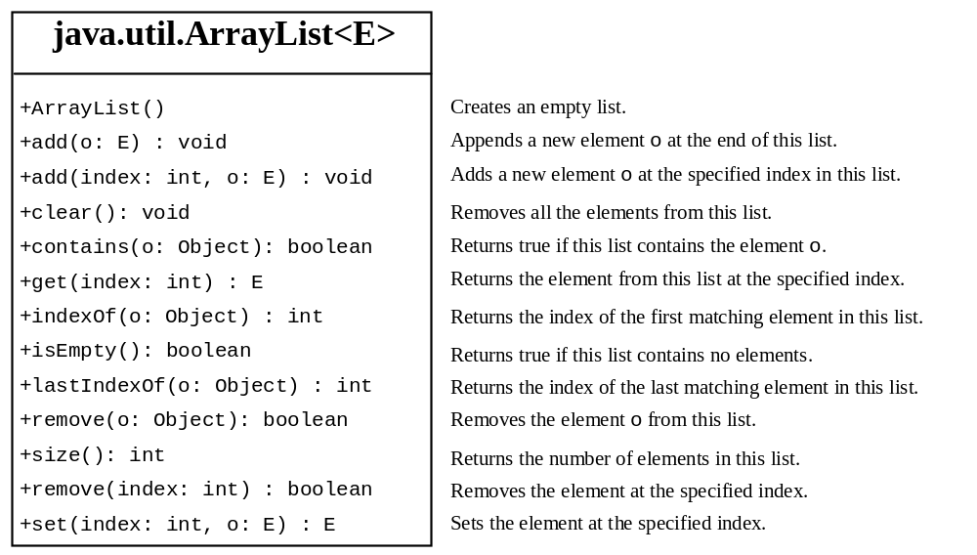

- ArrayList is known as a generic class
- When you create an ArrayList, you specify a concrete type that replaces the generic type (E)

Example
- To use you must import java.util.ArrayList

ArrayList<String> myList = new ArrayList<>();
ArrayList<Animal> zooAnimals = new ArrayList<>();

- Notice the difference from declaring a regular array

int[] integerArray = new int[10];
Regular brackets are used
Angle brackets are used
ArrayList<String> myList = new ArrayList<>();
Kind of strange looking but
need both angle brackets
and parenthesis
- See example in Listing 11.8 to see the different operations being used on an ArrayList

Compared to Arrays
- Arrays
  - Size must be specified when you create the array
  - Accessing elements is done with the bracket notation
  - Can get overflow issues if access outside limits of array
  - Size is stored in length property

- ArrayList
  - Size is NOT specified when you create the array
  - Accessing elements is done with methods - add(), get() and set()

zooAnimals.add(new Hippo());
zooAnimals.add(new Lion());
zooAnimals.add(new Tiger());

for (int i = 0; i < zooAnimals.size(); i++) {
Animal aAnimal = zooAnimals.get(i);
}

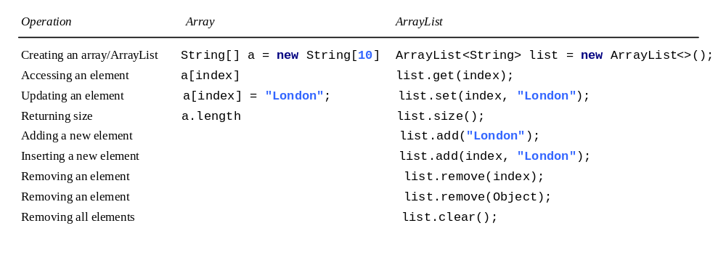

Useful Methods for Lists

Creating ArrayList from an Array
- There are times when you need to create an ArrayList from an Array
- There are a couple of ways to do this
  - Write a loop

String[] myStrings = {"Jan", "Feb", "March", "April", "May"};
ArrayList<String> arrayListOfStrings = new ArrayList<>();

for (int i = 0; i < myStrings.length; i++) {
arrayListOfStrings.add(myStrings[i]);
}

  - Use methods provided by Java. Static method on Array called asList

String[] myStrings = {"Jan", "Feb", "March", "April", "May"};
ArrayList<String> arrayListOfStrings = new
ArrayList<>(Arrays.asList(myStrings));

Creating Array from an ArrayList
- You can also create an array from an ArrayList
- There are a couple of ways to do this
  - Write a loop

String[] stringList = new String[5];

for (int i = 0; i < stringList.length; i++) {
stringList[i] = arrayListOfStrings.get(i);
System.out.println(stringList[i]);
}

  - Use methods provided by Java.

String[] stringList = new String[5];
arrayListOfStrings.toArray(stringList);

Other Methods
- There are several methods in the Collections class that you can sent an ArrayList to
- sort
- min
- max
- shuffle

The protected Data and Methods

Modifiers
- Public
  - Indicates that the class, method or variable can be accessed from ANY other classes
  - Can apply to class or members of a class (variables/methods)

- Private
  - Indicates the method or variable can be accessed ONLY from within its own class
  - Can apply only to members of a class (variables/methods)

- Default (Package-Private)
  - Tied to packages
  - When no modifier is specified, default is the modifier
  - Indicates the class, method, or variable can be accessed by any class within the same package

- Protected
  - Indicates the method or variable in a class can be accessed from a subclass.
  - Protected methods and variables can also be access by methods of classes in the same package.

Purpose
- When dealing with subclasses, many times you want access to the data fields or methods of a superclass
- Protected provides a subclass access while non-subclasses no access

Visibility Overview
Visibility increases
- - - - - - - - - - - - - - - - - - - - - - - - - - - - - - - - - - - - - - >
private none protected public

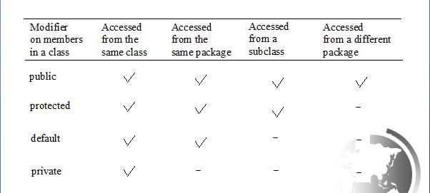

Notes
- Use private
  - To hide data fields and methods completely
  - Nothing outside of the class can touch private elements
  - Use on data fields and methods that are not intended for use outside of the class

- Use default (no modifier)
  - To allow data fields and methods to be accessed by another class in same package

- Use protected
  - To allow data fields and methods to be accessed in a subclass or another class in same package
  - Use on data fields and methods that need to be used in a subclass

- Use public
  - To make data fields and methods accessible to all classes
  - Use on date fields and methods when they need to be used outside the class

- Difference between default and protected
  - Very similar but differ only when we talk about subclasses
  - A default data field or method may be accessed ONLY if the class accessing it belongs to same package.
  - A protected data field or method can be accessed (through inheritance) by a subclass even if the subclass is in a different package.

- Subclass cannot weaken accessibility
  - A subclass can override a protected method
  - When overriding a protected method, the subclass can change the visibility of the method

  - The rule - the subclass cannot change the visibility to something less visible!
  - Therefore, method's visibility could be changed to public in the subclass.

Preventing Extending and Overriding

Preventing Inheritance
- There may be times you do NOT want a class to ever become a superclass (parent)
- To do this, use the keyword final on class

public final class Book { Because defined as "final" is class can never be a parent!
public Book() {
}
}

Prevent Overriding
- There may be times you do NOT want a method to ever be overridden in a subclass
- To do this, use the keyword final on the method

class Book {

public Book() {
}

public final cannotChangeMe() {
// Some code
}

}

class Mystery extends Book {

public Mystery() {
} Attempting to override the method causes a compiler error -
@Override Cannot override the final method
public void cannotChangeMe() { from Book

}

} // Mystery

Note
- We've used the final keyword before - on variables - this made the variable a constant!

final double pi = 3.14;

- Now we see final being used on classes and methods to prevent them from changing.

